SMART Targets 7th Grade
Unit 6.1: “Another Place, Another Time” (p. 93-106)

On-going
- Comprehension questions from story (CLASSWORK grade)

- Language Tasks: Critical Vocabulary/Vocabulary Strategy p. 109; Language Conventions p. 110 (CLASSWORK grade)

- Project: Mood project (PROJECT grade)

- i-Ready (one 45’ lesson and accompanying quiz per week)

Assessment
- Analyzing the Text p. 108 (CLASSWORK grade)
- Comprehension Test – (TEST grade)

7th Grade ELA Comprehension Questions
Unit 6.1: “Another Place, Another Time” p. 93-106 by Cory Doctorow

Day 1 – lines 1-66 (p. 93-95)
- ANALYZE STORY ELEMENTS – CHARACTER: One story element can often reveal information about another story element. For instance, setting, the time and place of the action, can influence the characters in a story. Re-read the first paragraph, lines 1-7 (p. 93). A. Identify the different settings Gilbert is thinking of. B. What do these settings reveal about Gilbert? (RL.1.3)

- ANALYZE STORY ELEMENTS – CHARACTER: All stories have a main character, the character whose problem or goal drives the plot. Authors often reveal information about a characters by showing how they interact with each other. Re-read lines 31-44 (p. 94). A. Identify the main character and the problem that is being explained. B. Cite evidence from the text that shows what the other characters may think about him. (RL.1.3)
Day 2 – lines 67-205 (p. 95-99)
- DETERMINE MEANING OF WORDS AND PHRASES: A symbol is a person, place, object, or activity that stands for something beyond itself. Throughout the story, the author uses different symbols to emphasize the importance of time to Gilbert. Re-read lines 82-87 (p. 95). A. Identify a symbol that suggests the passing of time. B. Use evidence from the text to explain what it reveals about Gilbert. (RL.1.1, RL.2.4)

- ANALYZE STORY ELEMENTS – CHARACTER: A character’s motivation is the reason for a character’s behavior. Re-read lines 131-135 (p. 97). Cite details that reveal one of Gilbert’s motivations. (RL.1.1, RL.1.3)
Day 3 – lines 206-320 (p. 99-103)
- ANALYZE STORY ELEMENTS – CHARACTER: Characters often behave differently in different settings. In addition, children behave differently when adults are not present. Re-read lines 211-231 (p. 99). A. How does the characters’ freedom from adult supervision affect their behavior? B. How does Gilbert “make the most of” this time in his life? (RL.1.3)

- ANALYZE STORY ELEMENTS – CHARACTER: Sometimes authors explicitly describe a character’s traits. More often, however, they provide evidence of character traits and expect readers to infer, or make good guesses about, them. Re-read lines 235-249 (p. 100). Identify ways in which the children are determined. (RL.1.1, RL.1.3)
Day 4 – lines 321-421 (p. 103-106)
- ANALYZE STORY ELEMENTS – CHARACTER: In the end, Gilbert makes a bold move to leave the other children behind and set out on his own. Re-read the last three paragraphs of the story (lines 414-421, p. 106). Identify what Gilbert does and explain what this action reveals about him. (RL.1.3)
Grade 7 - Mood Project
“Another Place, Another Time”

- Re-read the pages from the text that have been assigned to you.
- Decide on at least two (2) adjectives that describe the overall mood of each page. Include those adjectives on the page of text.
- Circle the words and phrases that helped you determine the mood. (Remember mood is the atmosphere of a piece of writing; it’s the emotions a selection arouses in a reader. Think about how that page of the story makes you feel)
- Then create a colorful image on the page of text. The image should reflect the moods you listed on the page. You must use colored pencils or crayons (no markers). The idea is that the author’s words still show through. Example image below.
- Provide a one-paragraph explanation of your images and their connections to the overall moods you identified.
Example:
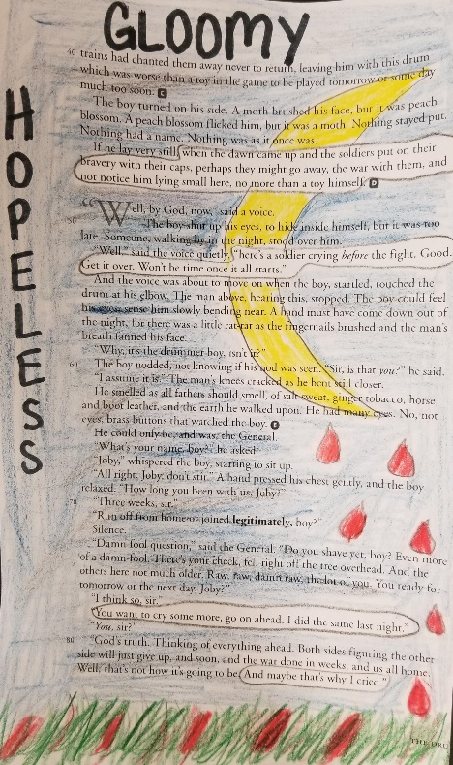
Positive Mood Word Possibilities:
amused, loving, happy, peaceful, playful, relieved, satisfied, passionate, hopeful, confident, optimistic, surprised, thankful, joyous, content, pleased, grateful, harmonious, welcoming, dreamy, etc.
Negative Mood Word Possibilities:
lonely, grumpy, gloomy, annoyed, disappointed, rejected, scared, stressed, confused, overwhelmed, dreary, heartbroken, serious, somber, worried, uncomfortable, anxious, aggravated, hostile, etc.

